**Test Document for Receipt Date required in Input tax credit utility**

In session “Process input tax credit lines-tfacp9600m00l” Receipt date is shown.

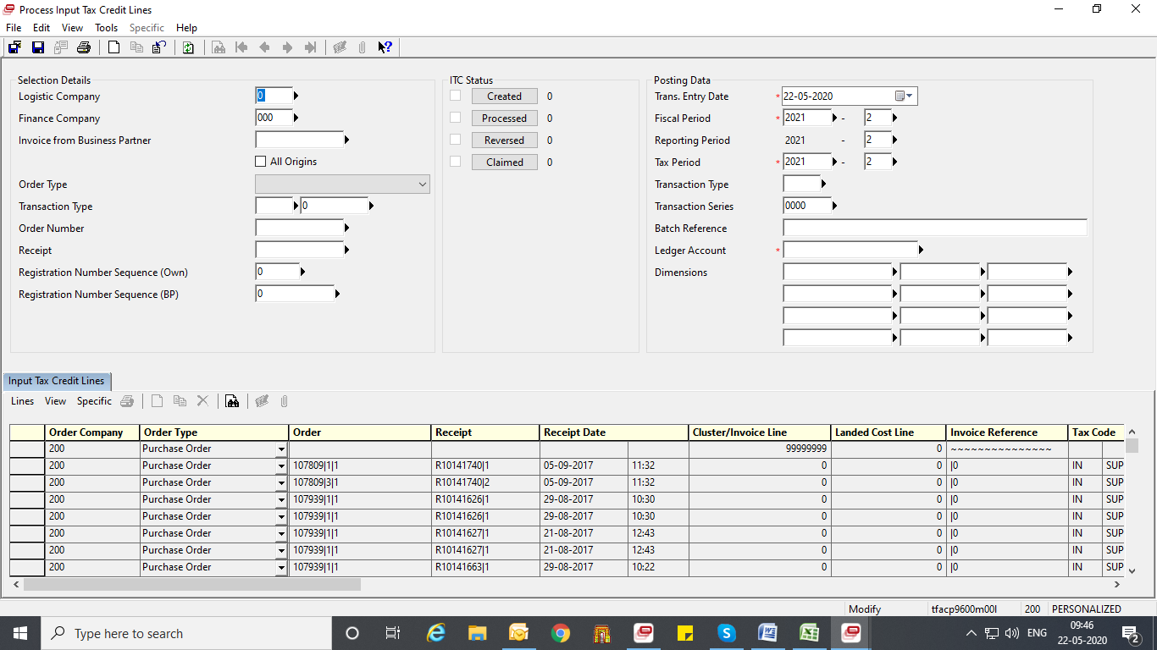

In session, Input tax credit utility - tfisg9257m000 Receipt date is shown,

